Lab 4

Johanan Seeruthen

G00419446

15/02/24

**Question 1:**

Question 2:

Question 3:

Question 4:

Question 5:

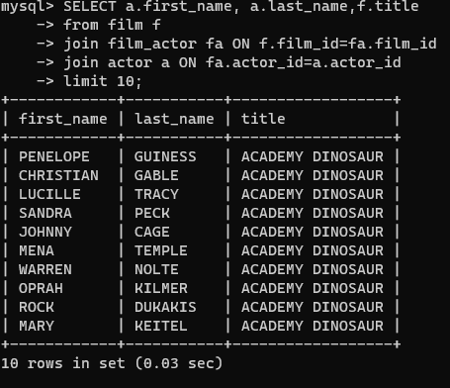

Question 6:

Question 7:

Question 8:

Question 9: